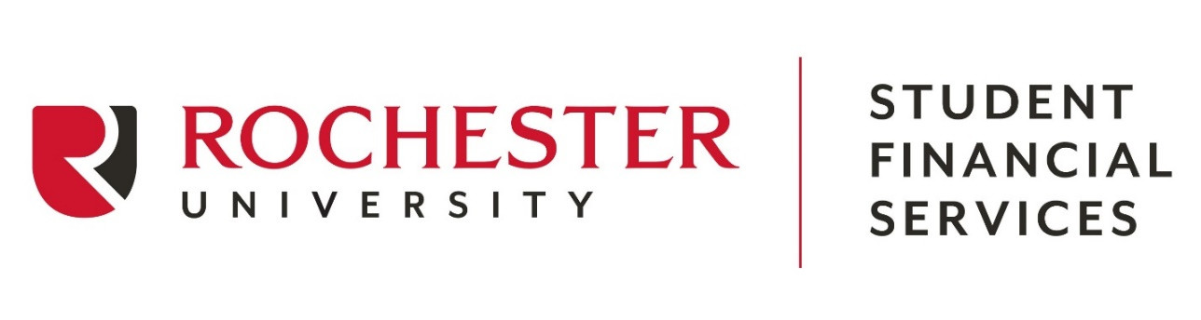

Student Financial Services
800 West Avon Road

Rochester Hill, MI 48307
248-218-2127

2023-2024 FINANCIAL AID CHANGE FORM

Return this form to the Student Financial Services Office to report the following changes or updates ONLY:
- To reduce award amounts

Student Name _____________________________________________ Social Security Number _________________________
Last First MI

Telephone (______) __________________________________ Email ______________________________________________

Award Reductions – Please complete this section to reduce the amount of an award that the Rochester University Student Financial Services Office has packaged. Please enter the net amount that you wish to receive. When you have completed this section, proceed to the signature box below.

 | Amount Requesting for  Fall 2023 | Amount Requesting for Spring 2024 | Amount  Requesting for Summer 2024 | Total Amount  Requesting for  2023-2024
PLUS Loan¹
Unsubsidized Stafford Loan
Subsidized Stafford Loan
Federal Work Study
Other:

¹ The parent that signed for the PLUS loan must also sign in the signature box below.

SIGNATURE BOX: Your signature is required to make changes to your financial aid award(s).

My signature certifies and confirms that I have read and understand all instructions and that I have provided accurate, complete and current information.

Student Signature ___________________________________________________ Date _____________________

Parent Signature (only required for PLUS loan adjustments)

__________________________________________________________________ Date _____________________

