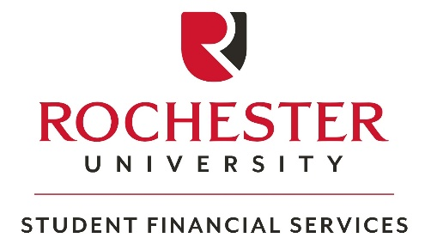
Statement of No Parental Support
2023-2024 (Fall 2023, Spring 2024, Summer 2024₎
Name:
Student’s Name (Last, First, M.I.)
If you completed the Free Application for Federal Student Aid (FAFSA) and did not report your parent’s information because of unusual circumstances go to section 1. If your parent refuses to provide their information on the FAFSA go to section 2.

Dependency Override: Select the option below that most accurately reflects your circumstances.

Note: The Federal Government places the primary responsibility for financing a college education on the student and his or her family; therefore, the following circumstances do not, in and of themselves, warrant a Dependency Override:
- Parental refusal to complete the FAFSA form.
- Parents not claiming the student as an exemption on their Federal taxes.

- My request to be independent of my parents for financial aid purposes was approved last year and my family situation has not changed. Supporting documents not required, but we may follow-up with you.

- I have an unusual family situation, making it difficult to obtain my parents’ information. Examples include, but are not limited to: abusive family environment, abandonment, incarceration or institutionalization of both parents, parents lacking the physical or mental capacity to raise a child, parents cannot be located, etc. Must submit supporting documents below. We may ask for additional documents.*

*To complete an appeal for a dependency override, submit the following items along with this form:
- A written statement describing your special circumstance(s).
- Two letters from outside parties (i.e. counselors, teachers, physician, clergy member) who have knowledge of your circumstances. Letters can be on official letterhead or notarized.

2. Parent Refusal
My parent(s) do not want to provide their information on the FAFSA and they do not and will not provide any financial support for me. Financial support includes payment of educational expenses, cash and non-cash support, or any living expenses (including living at home with my parents). To approve a Federal Direct Unsubsidized Loan, we require the following certification from your parent.

PARENT REFUSAL CERTIFICATION

I understand that by refusing to provide information on the FAFSA my child will not be considered for Federal Pell Grant, other federal or state grants, work-study, or Federal Direct Subsidized Loans. I understand that my child will only be eligible for a Federal Direct Unsubsidized Loan, which may not cover all of the educational expenses. I also understand that I can make a correction to the FAFSA to enter my financial information so my child can receive full financial aid consideration and that doing so does not obligate me to borrow educational loans on my child’s behalf or pay my child’s tuition or other charges. I certify that I ended all financial support for my child on: _______________. (Date support ended)

___________________________________________________ ________________
Parent Signature Date

By signing this form, I certify that all the information provided is complete and accurate.

______________________________________________________________ ________________
Student Signature Date

Electronic and typed signatures are not acceptable.

Please submit your form in person, by email to sfs@rochesteru.edu, by fax to 248.218.2065, or by mail to: Rochester University, ATTN: Student Financial Services, 800 W Avon Rd, Rochester Hills, MI 48307

